Los Angeles Unified School District
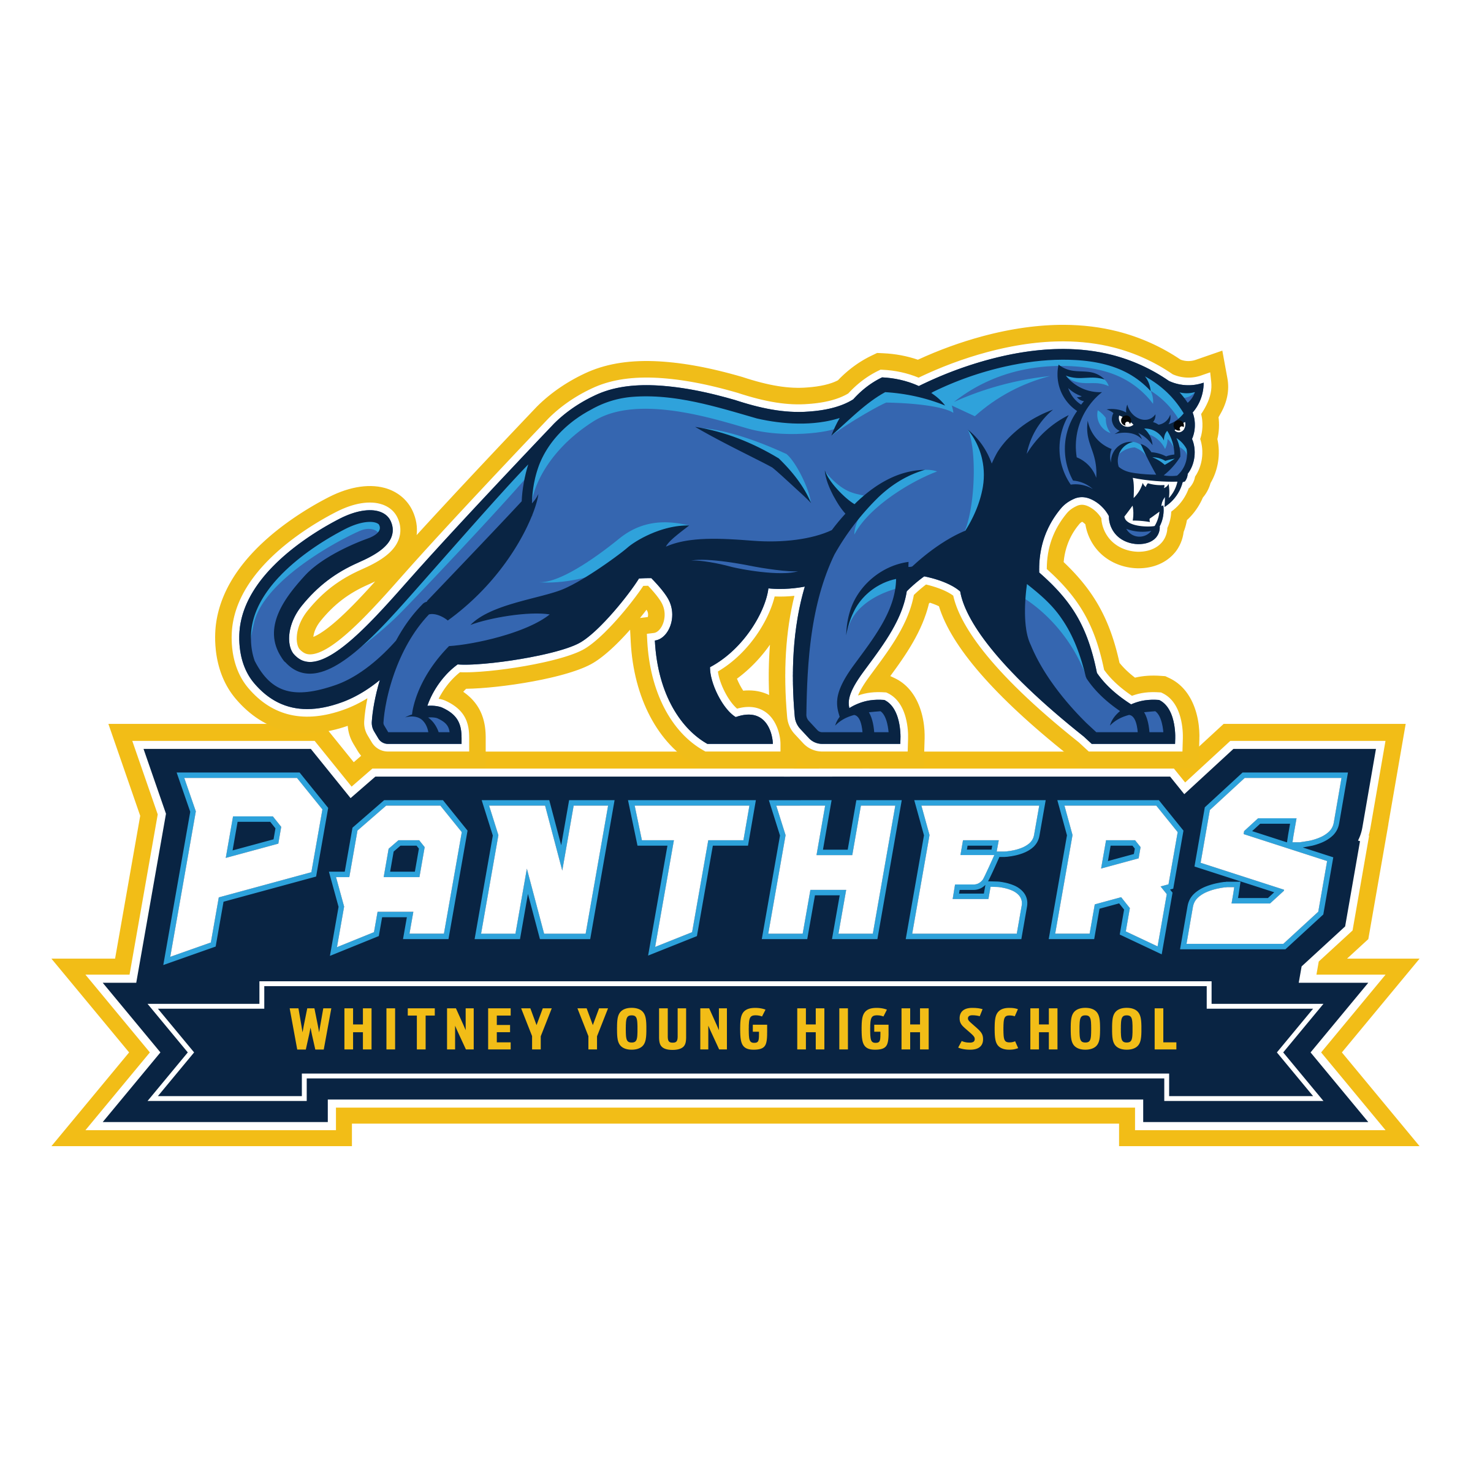
Whitney Young High School
School Site Council (SSC) Agenda
Friday, December 5, 2025, 10:15 am, Room C

I. Welcome/Call to Order
II. Roll Call
III. Flag Salute
IV. Minutes
V. New Business
A. Comprehensive Needs Assessment
B. Single Plan for Student Achievement
C. Budget - 2026 - 2027 School Year

VI. Public Comments
VII. Adjournment

Meeting Dates:
● January 23, 2026, 1:30 pm

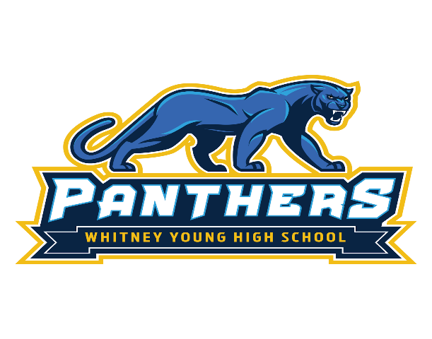
Whitney Young High School
School Site Council Meeting 
Friday, December 12, 2025, 1:30 pm
Room C
- Comprehensive Needs Assessment
- Single Plan for Student Achievement (SPSA)
- Budget - 2026 - 2027 School Year
- Updates

Flyer – 12/8/2025

